## Elders/Knowledge Holders Educators’ Handbook

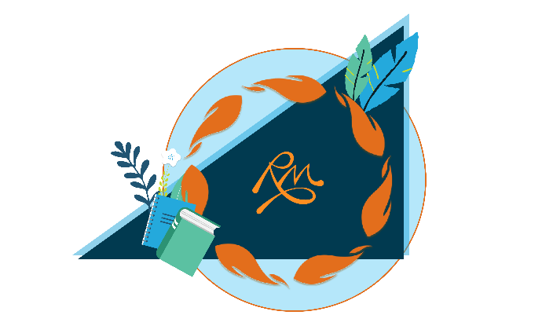

Table of Contents

Acknowledgements **3**

Introduction 4

Instructions for Using the Elder/Knowledge Holder in the Classroom 5-10

Request for Resources 11

Presentation Ideas 12-17

Important Considerations 17

Indigenous Education Support Request Form 18

Elders/Knowledge Holders Job Section 19

Elders/Knowledge Holders Job Description 20

Elders/Knowledge Holders Invoice Form 21

Feedback Form 22

Door Signs 23/24

References 25

### Acknowledgements

We acknowledge, respect, and honour the unceded territorial land of the Ktunaxa and the Secwepemc people.

We could not do this important work without the support and guidance of the Indigenous communities, Elders and Knowledge Holders. Thank you.

This handbook was inspired by documents created by other institutions, as referenced in the section titled “References.” We are very appreciative of the work done in this area.

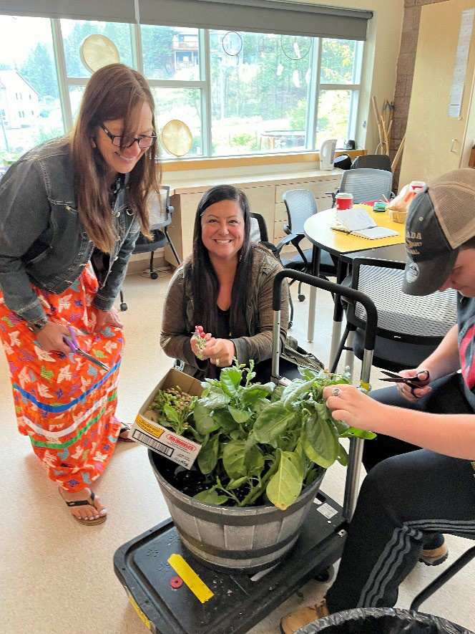

### Introduction

Greetings! We would like to thank you for taking the time to review this handbook. Rocky Mountain School District 6 has been working towards creating environments that are inclusive and honouring of all cultures. This is important for many reasons, but primarily to support our students.

In order to ensure that our students have the best experience at school possible, it is essential to invite and include Elders and Knowledge Holders. We will strive to make sure that Elders feel safe, respected, and valued as they help us.

We would like to thank you for taking the time to learn about these protocols and for your best intentions for including Elders in our school district. We hope that you find this information helpful.

Please note that this is a living document and will be updated regularly. If you have any additions/corrections/edits, please let the District Principal of Indigenous Learning and Equity know.

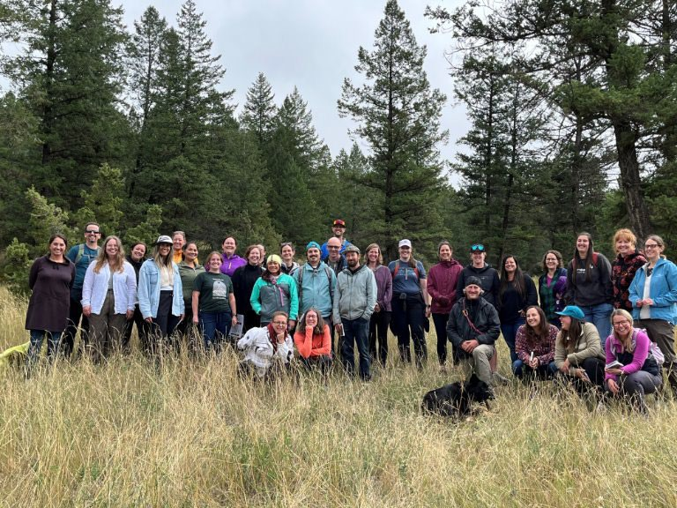

### Vulnerable Sector Criminal Records Checks

In consultation with our Elders/Knowledge Holders and Indigenous Partners Committee, we have agreed that Vulnerable Sector Criminal Records Checks are important for Elders/Knowledge Holders to have before coming to work with our students.

As our Elders/Knowledge Holders come in regularly to work with our students, classes, groups or schools and may at times be required in an emergency situation to supervise students on their own, they are under the same legislative requirements as any other volunteer in our buildings.

We want to ensure that we are doing everything reasonable to protect the students in our care, so please ensure that the Elder/Knowledge Holder has a Vulnerable Sector Criminal Records Check either shared with your school principal or our Manager of Finance if the are working with more than one school in our District.

Please go to [https://www2.gov.bc.ca/gov/content/safety/crime-](https://www2.gov.bc.ca/gov/content/safety/crime-prevention/criminal-record-check/applicants/apply) [prevention/criminal-record-check/applicants/apply](https://www2.gov.bc.ca/gov/content/safety/crime-prevention/criminal-record-check/applicants/apply) for the application process.

### Before the Elder/Knowledge Holders’ Presentation

1. Consult with the school Principal and the Indigenous Education Support Worker regarding the date, time and focus/curriculum area.
2. Fill out the request form and submit it to the Indigenous Education Support Worker/Principal.
3. The Indigenous Education Support worker will:
   1. Ensure the Elder/Knowledge Holder(s) is on the approved district list

### Set up the date/time of the presentation with the Knowledge Holder(s)/Elder, unless the staff member would like to do so. Presentations can be a great way for staff members to develop relationships with Elders/Knowledge Holder as part of their own professional growth. We want to be mindful of not overwhelming our Elders and Knowledge Holders with requests, so it is best to discuss as a team who would be the best person to reach out.

* 1. Ensure Honorarium form is filled out.

1. Determine and share the purpose of the visit with your students. How is it connected to the curriculum? Be clear about the intended curricular outcomes connected to the visit so that it is a meaningful experience for all (for presentations, not residence program)
2. Ensure the Elder/Knowledge Holder is aware of the learning that has taken place prior to the visit. Please advise them of your time schedule so that they can adjust their presentation accordingly.
3. Ask the Elder/Knowledge Holder if they have any specific needs prior to the visit: Photocopying? Special equipment or supplies? Is there anything the students should know before the visit? Organization of the classroom/space?
4. Confirming and Reminding: Once an Elder has agreed to attend your event or classroom, it is a good idea to phone them a week or a few days in advance of your event to confirm that they are still able to come. If something has changed and the Elder is now unable to come, of course, do not get upset or panic. There may be someone else who can come on short notice – plans change! Reach out to your network to see who else might be available, and the Elder may even have a suggestion or recommendation.

### Day of Visit

1. Prepare classroom space as required. If technical equipment is required, check that it is working.
2. Please ensure that the IESW and/or teacher are with the Elder/Knowledge Holder at all times.
3. Welcome the Elder/Knowledge Holder at an assigned meeting place (office, parking lot, etc.). Assist them with their belongings and walk them to the classroom.

*Tip: Student leaders from your school can be trained for this important role ahead of time. Often students are honoured to be chosen for this role. Students can benefit from the extra one-on-one time spent with an Elder. Perhaps you have a student in mind who might need some extra encouragement from an Elder or time with a role model – a great “byproduct” of this role!*

1. Offer water/tea/coffee. Let them know where washrooms are located.
2. Acknowledge territory *(Check with the Elder/Knowledge Holder of their preferred land acknowledgement. It may be different than Rocky Mountain School District’s and that is okay)* and introduce the speaker to students.When an Elder/Knowledge Holder is in attendance at your event or meeting, it is appropriate to introduce him/her as an Elder/Knowledge Holder and offer thanks publicly for attending in that role. It is important to ask the Elder ahead of time as to preferences for being introduced (ex. first name or Mr/Mrs/Ms.

, role in community, nation, etc.).

1. \****It is important that the classroom teacher be present throughout the presentation***. Besides being respectful, this behavior also reinforces to students that the guest and the information being shared is important. Teachers also need to be available to address any student behavioural challenges. **Note:** *If you are unable to be present, please arrange/rearrange for an alternative date that works for you and the Elder/Knowledge Holder.*
2. Have student(s) formally thank the speaker and ensure that the gift is presented and inform the speaker that the honorarium will be mailed to them.
3. Some Knowledge Holders or Elders may share deeply personal experiences with students during their visit. Please ask them if they wish to have a few moments in a quiet place to ground themselves after the session.
4. If possible, debrief the session with the Elder/Knowledge Holder.
5. If you take photos of an elder, please make sure you have permission from them to use on social media or district publications.
6. Walk the Elder/Knowledge Holder out and assist them with any of their belongings.
7. **Honoraria**: An honoraria will be provided for Elder/Knowledge Holders who share their gifts, talents and skills in our schools.
8. Please complete an Elder/Knowledge Holder In Residence invoice form and scan/email it to the school administration and the school Indigenous Education Support Worker for authorization.

For more information, please review the guide to working with Elders [FPCC-Working-](https://fpcc.ca/wp-content/uploads/2021/05/FPCC-Working-with-Elders_FINAL.pdf) [with-Elders_FINAL.pdf](https://fpcc.ca/wp-content/uploads/2021/05/FPCC-Working-with-Elders_FINAL.pdf)

### Elder/Knowledge Holder in Residence

**Vulnerable Sector Criminal Record Checks:** Elders/Knowledge Holders in Residence are subject to a successful criminal record check through the volunteer form at the local RCMP detachment. Applicants must go in person to pick up/complete an original form and submit it, and then pick it up once completed and provide a copy to the School or Board Office. To ensure confidentiality, only school principals or the Finance Manager at the District Office will receive CRCs for records keeping.

### Things to Consider

**Gifting/Offering Tobacco**

Tobacco, wrapped in a cloth bundle, is often given as a gift to an Elder when a request is made for their services/knowledge or when a blessing/welcome/closing is offered, etc. Not all Indigenous people practice this, but it is common across many nations. When an Elder/Knowledge Holder accepts your gift, he/she is acknowledging that your request is accepted. In this way, it may be appropriate to place your offering of tobacco down in front of an Elder to allow for an acceptance of the request. By handing the tobacco over you are potentially taking the choice away from the Elder. If you are requesting something over the phone, you can offer a gift of tobacco upon first meeting with an Elder.

Because this is seen as a cultural practice, there are no issues with bringing tobacco into the school for this purpose, and, in fact, it is a great opportunity to educate students about ceremonial tobacco.

Traditional tobacco has been used by many Indigenous people to:

* Pray;
* Give thanks to the Creator and Mother Earth;
* Communicate with the spirits and
* Purify the mind and heal the body.1
* Laying of tobacco for protection

### Helpers:

Often, Elders/Knowledge Holders come with a family member or friend to assist them on their journey to your school with transportation or other types of support. Be prepared for this and consider asking the Elder/Knowledge Holder in advance if they will be bringing anyone else so that you can be prepared.

### Meals

If an Elder is there during meal times, it should be expected that you provide a meal for the Elder and their helper. Some of our Elders have special dietary restrictions/allergies/concerns, and this should be discussed ahead of time to avoid any problems.

1 Retrieved from: <http://www.hc-sc.gc.ca/fniah-spnia/substan/tobac-tabac/index-eng.php#use>

Due to the higher rates of diabetes in our Indigenous communities, some of our Elders are on special diets to help prevent or manage diabetes or other conditions impacted by diet and nutrition.

### Role of Audience

It is important that students know how to behave in the presence of an Elder/Knowledge Holder. This should be discussed ahead of time so students can be prepared and ask questions about what to expect. Students should be told about how to listen respectfully and that when Elders/Knowledge Holders share their knowledge, they are sharing gifts. It should also be discussed that sometimes our time with Elders takes longer than planned. This may mean, for example, that an activity planned before lunch may run into the lunch break by a few minutes. It is important that students are prepared to wait until it is appropriate to leave the space, etc. If there are any ceremonial protocols to be shared, this should be done ahead of time when possible. At the time of the event/activity, Elders should not be responsible for attending to/managing student behaviours. Make sure you are making your best efforts to encourage respectful listening, questions, and interactions. Here are some basics:

* We are a task oriented, not time oriented people – be patient;
* Stand up when an Elder is offering a prayer/blessing;
* Do not side talk, text, or use phone in any way when in ceremony or listening to an Elder share;
* Be in the moment, be present; and
* Be understanding and compassionate for others. Difficult stories may be shared in these trusting environments.

*Please share your successes and send us photos with permission if you have them, along with a brief description.

**Request for Resources**

Please check for authentication through the resources below first. If you cannot find an answer, please send your request to the school's Indigenous Education Support Worker, who will then access the District Principal of Indigenous Learning and Equity to confirm if necessary. Please allow 2 weeks for feedback.

[Focused Education Resources](https://focusedresources.ca/en/k-12-evaluated-resource-collection?search_api_fulltext&field_resource_author&title&field_switcher=search-api-fulltext&field_language=All&field_resource_subject=All&field_resource_collection%5B0%5D=indigenous)

[Searchable Database for Authentic First Peoples Resources](https://resources.fnesc.ca/) [Canadian Indigenous Books for Schools](https://books.bc.ca/wp-content/uploads/Indigenous2019_forWeb-singles_Nov1.pdf)

[Strong Nations Indigenous Labels](https://www.strongnations.com/)

[Cultural Appropriation vs. appreciation (teacher resource)](https://etfofnmi.ca/wp-content/uploads/2023/12/ETFO-Cultural-Appropriation-Revised-2022.pdf)

**School Presentations:**

* Are they local? If not, have you talked with the Indigenous Education Support Worker?
* Are they vetted through the local Indigenous communities?
* Please communicate with the Indigenous Education Support Worker, who will then connect with the District Principal of Indigenous Learning and Equity.

**Collaboration/Consultation:**

* If you are interested or have ideas on a topic, project or unit plan that you would like to explore further, please provide a short description and send your request to Jenny Reid via email at [jenny.reid@sd6.bc.ca](mailto:jenny.reid@sd6.bc.ca).

## Indigenous Education Presentation Ideas

Please note that this is not an exhaustive or prescriptive list and that you should connect with your knowledge keeper/elder to get their ideas and input on your specific presentation and come up with the best fit for your class, curriculum and context.

|  |  |  |
| --- | --- | --- |
| **Primary (K-3)** | | |
| **Subject** | **Curriculum Connections** | **Examples** |
| ELA | Show awareness of how story in First Peoples cultures connects people to family and community | Share Creation Stories  <https://www.ktunaxa.org/who-we-are/creation-story/)> [https://secwepemcstrong.com/secwepemc-pre-contact-](https://secwepemcstrong.com/secwepemc-pre-contact-history/) [history/](https://secwepemcstrong.com/secwepemc-pre-contact-history/) |
| Science | Recognize First Peoples stories (including oral and written narratives), songs, and art, as ways to share knowledge | Share First Peoples knowledge of the sky. Traditional stories about celestial objects. Students can then lace a constellation. |
| Science | First Peoples practice and knowledge of plant and animal use (e.g., local berries or food, plants and animals, conservation of resources) | **Gathering and Uses of Plants**: Students will learn about the characteristics of local plants and First Peoples’ uses of local landscape plants.  **Exploring Local Wildlife Animals**: Students will view examples of local animals and their tracks. They will learn some animal names in the local First Nations Languages. See [Ktunaxa Nature Walk: Alfred Joseph’s Walkabout](https://outdoorlearning.com/product/ktunaxa-nature-walk/) and  [?a-kxam̓is q̓api qapsin (All Living Things)](https://outdoorlearning.com/product/ktunaxa-ethnobotony/) |
| Science/ Social Studies | First Peoples knowledge of seasonal changes/ How people’s needs and wants are met in communities; diverse environment features; rights and responsibilities of individuals regionally and globally | **Traditional Fishing**: The importance of Salmon to the Ktunaxa and/or Shuswap people. Learn about the salmon life cycle and traditional vs. contemporary fishing techniques. |
| Social Studies/ Physical Education | Personal and family history and traditions/How to participate in different types of physical activities including individual and dual activities, Rhythmic activities and games (traditional Indigenous games) | **Traditional Games**: Students will be introduced to accuracy and intuition games used to hone hunting skills and beginning hand commands of the traditional stick game to use in their classrooms.  **Traditional Dance:** In a gym, various types of regalia, dance steps, and the importance of traditional dancing are demonstrated and discussed. |

|  |  |  |
| --- | --- | --- |
|  |  | Metis Dance: <https://www.youtube.com/watch?v=GAGgWGfvEHE&t=3s> |
| **Primary (K-3) Continued** | | |
| Social Studies | Diverse characteristics of communities and cultures in Canada and around the world, including at least one Canadian First Peoples community and culture. | **Traditional Beading**: Personal Pouches – Students will create a personal ‘necklace’ pouch. The hide tanning process is described along with the uses of pouches. The students decorate their pouches with traditional symbols. Medicine Wheel Necklaces **-** The four colours of the Medicine Wheel are used for beading and patterning, along with a cultural talk about the characteristics of the Medicine Wheel. |
| Social Studies | Cultural characteristics and ways of life of local First Peoples and global Indigenous peoples; interconnections of cultural and technological innovations of global and local Indigenous peoples | **Traditional Dwellings**: Using explanations and examples about the tipi or pit houses.  Sharing of traditional stories about local land formations. |

|  |  |  |
| --- | --- | --- |
| **Elementary (4-7)** | | |
| **Subject** | **Curriculum Connections** | **Examples** |
| Social Studies Physical and Health Education/ Arts | **Social Studies:** Media technologies and coverage of current events **/ Physical and Health Education:** Identify, apply, and reflect on strategies used to pursue personal healthy-living goals. **Arts:** Interpret and communicate ideas using symbols and elements to express meaning. | **Stereotyping / Medicine Wheel:** Discuss how various media affects perceptions of First Peoples and often leads to misunderstandings.  Traditional teachings about the Medicine Wheel. This symbol represents the foundational belief of Indigenous culture. The lesson centers on the physical, intellectual, emotional, and spiritual aspects, how to bring ourselves into balance as well as incorporating that all things are interrelated. Students may bead a bracelet to extend the symbolic meaning. |
| Social Studies/Art | **Social Studies**: Interactions between First Peoples and Europeans. **Art**: Traditional and contemporary Indigenous arts and arts-making processes. | **Traditional Beading**: Students will learn about common objects traded between First Peoples and early Fur Traders. Students make a key chain using different colours of beads representing a traded item.  Appliqued animals – Information on animals' importance and characteristics in Indigenous life. Students pick an animal to represent their own character and sew the edges onto a piece of fabric.  Personal Pouches - A hands-on sewing and beading activity creating a leather ‘necklace’ pouch that includes |

|  |  |  |
| --- | --- | --- |
|  |  | an informational session on the Medicine Wheel and the use of the Medicine bag. |
| **Elementary (4-7 Continued)** | | |
| Social Studies | The pursuit of valuable natural resources played a key role in changing the land, people and communities. | **Walkabout**: Students will explore local plant life and their traditional uses in either an outdoor ethno walk or an indoor presentation (the outdoor walk is seasonal). See [Ktunaxa Nature Walk: Alfred Joseph’s Walkabout](https://outdoorlearning.com/product/ktunaxa-nature-walk/) and  [?a-kxam̓is q̓api qapsin (All Living Things)](https://outdoorlearning.com/product/ktunaxa-ethnobotony/) |
| Social Studies | Economic policies and resource management, including effects on indigenous peoples**;** economic self-interest can be a significant cause of conflict. (grade 6) | **Traditional Resource Management**: The traditional management of resources by the Ktunaxa/Secwépemc people is explained and compared to modern resource management and global issues |
| Social Studies/Arts | **Social Studies:** Core beliefs and practices of one Indigenous people. **Arts:** traditional and contemporary Indigenous arts and arts-making processes**.** | **Traditional Drumming:** Students are given the opportunity to use rattles and hand drums to explore different songs. They are introduced to following protocols and demonstrating respect while using the drum. |
| Social Studies | The urbanization and migration of people**;** resource management including effects on indigenous people (grade 6) | **Indigenous Plants:** Students explore local plants and their traditional uses in either an outdoor ethnobotany walk (**seasonal field trip recommended**) or an indoor presentation. Students explore how Indigenous peoples and plants interact. |
| ELA/Social Studies | **ELA**: Recognize and appreciate the role of story, narrative, and oral tradition in expressing First Peoples perspectives, values, beliefs, and points of view.  **Social Studies:** global poverty and inequality issues, including class structure and gender | The importance of Oral history and traditional stories with a focus on different responsibilities, origins, core beliefs and social structures. |
| Science | The effects of the relative positions of the sun, moon, and Earth, including local First Peoples perspectives. | Students will make connections to stories through the understanding of oral history and traditional stories in Indigenous culture. |
| Physical Education | Proper technique for fundamental movement skills, including non-locomotor, locomotor and manipulative skills. | **Traditional Games:** In a gym or outside, various games are explained and played that are used to develop specific strengths. |
| Physical Education /Arts | **PE**: How to participate in different types of physical activities including rhythmic activities: dancing. **Arts**: | **Traditional Dance**: Various types of regalia, dance steps, and the importance of traditional dancing are demonstrated and discussed. |

|  |  |  |  |
| --- | --- | --- | --- |
|  | traditional and contemporary Indigenous arts and arts-making processes. | |  |
| **Middle School (8-9)** | | | |
| **Subject** | **Curriculum Connections** | **Examples** | |
| Social Studies | Social, political and economic systems and structures of an indigenous civilization. (grade 8) | **Indigenous Communities**: Components of a traditional and a contemporary Ktunaxa/Secwépemc community are discussed, including governmental issues | |
| Social Studies | Exploration, expansion and colonization: the continuing effects of imperialism and colonialism on indigenous peoples in Canada and around the world (grade 8) discriminatory policies, attitudes, and historical wrongs (grade 9) | **Colonization - Blanket Exercise**: An interactive activity that visually represents the colonial effects of the Canadian Government on First Nations Peoples. | |
| Arts | Traditional and contemporary Indigenous arts and arts- making processes. | **Traditional Beading**: Beaded necklace - A beading activity using beads and rope with an informational session about the role of trade, materials, and usage, with an emphasis on patterning. | |
| Physical Education | Proper technique for fundamental movement skills, including non-locomotor, locomotor and manipulative skills. | **Traditional Games:** In a gym or outside, various games are explained and played that are used to develop specific strengths. | |
| Physical Education/Social Studies/Arts | **PE**: How to participate in different types of physical activities including rhythmic activities: dancing. **Social Studies**: Core beliefs and practices of one indigenous people. **Arts**: traditional and contemporary Indigenous arts and arts-making processes. | **Traditional Dance**: Various types of regalia, dance steps, and the importance of traditional dancing are demonstrated and discussed. | |
| Social Studies | Scientific and technological innovations of an indigenous civilization  In what ways has colonization made life better or worse? For whom? | **Environment: Fishing-Salmon** Traditional fishing implements introduced versus modern methods of fishing. Salmon ceremony discussed.  Students to draw conclusions on how fishing techniques impact our natural resources. | |
| Science | Apply First Peoples perspectives and knowledge, | **Walkabout**: Students will explore local plant life and their traditional uses in either an outdoor ethno walk or an | |

|  |  |  |
| --- | --- | --- |
|  | other ways of knowing, and local knowledge as sources of information | indoor presentation (the outdoor walk is seasonal). See [Ktunaxa Nature Walk: Alfred Joseph’s Walkabout](https://outdoorlearning.com/product/ktunaxa-nature-walk/) and [?a-](https://outdoorlearning.com/product/ktunaxa-ethnobotony/) [kxam̓is q̓api qapsin (All Living Things)](https://outdoorlearning.com/product/ktunaxa-ethnobotony/) |
| **Middle School (8-9) Continued** | | |
| Science | First Peoples knowledge of:   * local geological formations * significant local geological events |  |

|  |  |  |
| --- | --- | --- |
| **Secondary (10-12)**  *Please note: All presentations demonstrate "cultural and social awareness" as in the Career Education K-9 Curriculum. Many of the presentations from the other grade levels would also be appropriate in a secondary setting.* | | |
| **Subject** | **Curriculum Connections** | **Examples** |
| Social 10 | government, First Peoples governance, political institutions, and ideologies. Indian Act: Crown- and federal government–  imposed governance structures on First Peoples communities (e.g., band councils) title, treaties, and land claims | **Colonization - Blanket Exercise**: An interactive activity that visually represents the colonial effects of the Canadian Government on First Nations Peoples. |
| First Peoples 12 | Cultural expressions convey the richness, diversity, and resiliency of B.C. First Peoples |  |
| Francophone History and Culture 11 | local, regional, and national co- operation and conflicts between different groups, including First Peoples  -influence of First Peoples on migratory movements by French Canadians  -origins of the Métis Nation  - influence of Aboriginal cultures on the development of French- Canadian culture (e.g., maple syrup production, snowshoeing, canoeing) |  |
| 20th Century World History 12 | human rights movements, including indigenous peoples movements | [*Tsilhqot’in*](https://www.thecanadianencyclopedia.ca/en/article/chilcotin-tsilhqotin/) *v. British Columbia,* White Paper, Oka Crisis, Idle No More |

|  |  |  |
| --- | --- | --- |
| First Peoples 12 | Through self-governance, leadership, and self-determination,  B.C. First Peoples challenge and resist Canada's ongoing colonialism. | **Colonization - Blanket Exercise**: An interactive activity that visually represents the colonial effects of the Canadian Government on First Nations Peoples. |
| **Secondary (10-12) Continued** | | |
| Science 10/Anatomy and Physiology 12 | Apply First Peoples perspectives and knowledge, other ways of knowing, and local knowledge as sources of information | **Traditional Medicines**: Consult with local Elders and knowledge keepers to determine some health conditions that may be treated with First Peoples traditional medicines. Which body systems might be affected?   * How has the diversity of plants in your local area benefited First Peoples? * How are First Peoples traditional medicines prepared in your local area? * How would you safely determine the efficacy of a First Peoples traditional medicine? * How are First Peoples traditional medicines prepared for different uses? |
| Earth Sciences 11 | First Peoples knowledge of local plate tectonic settings and geologic terrains. First Peoples knowledge of climate change and interconnectedness as related to environmental systems. First Peoples knowledge and perspectives of water resources and processes | **Evidence of Climate Change:** both historical and recent (i.e., the last 100 years) climate change (e.g., ice core data, deep sea sediments, First Peoples knowledge)  How do First Peoples traditional practices contribute to dynamic equilibrium in an ecosystem? How do First Peoples perspectives and knowledge inform sustainable practices? |
| Environmental Science 11 | First Peoples knowledge and other traditional ecological knowledge in sustaining biodiversity. First Peoples ways of knowing and doing | **Traditional Stewardship:** agriculture, ethnobotany, forestry, fisheries, mining, energy, controlled burning, harvesting cycles. prescribed fire, selective harvesting, plant propagation and pruning |

### Important Considerations

The Rocky Mountain School Districts’ Indigenous Partners include the ʔakisq̓nuk First Nation and ʔaq̓am First Nation of the Ktunaxa, the Shuswap Band (*Kenpesq’t*) of the Secwépemc and MNBC Chartered Communities: Métis Nation Columbia River Society, Columbia Valley Métis Association, and the Rocky Mountain Métis Association.

Our focus is on representing local First Nations’ culture and language and using local resources whenever possible. It is also important to ensure that we reflect the diversity of our communities through our presenters as part of our commitment to our distinctions-based approach.

As each group of Indigenous Peoples have their own practices, traditions and cultures, we must ensure that the diversity of Indigenous Peoples are represented in our schools.

### A logo with orange leaves and a blue circle Description automatically generated with medium confidence Indigenous Education Support Request Form: School

School Name:

Today’s Date:

Teacher’s First Name: Last Name:

Grade Level: Number of all students Number of Indigenous Students

School Indigenous Education Support Worker:

Topic:

Date Requested: Time requested (For example, 1 hour):

Time during the day: Alternative Date(s):_ _ _ _ _ _ _ _ _ _ _ _ _ _ _ _ _

The Indigenous Education Program of Rocky Mountain School Disitrict 6 is funded through the School Budget. Submit this form to your Indigenous Education Support Worker or District Principal.

***For more resources, click*** [***here***](https://www.sd6.bc.ca/staff/indigenous-education) ***to visit our website.***

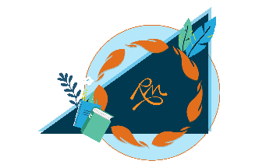

**Elders/Knowledge Holders Information**

Welcome to Rocky Mountain School District 6!

We want to express our sincere gratitude and appreciation to you for sharing your time, knowledge, skills and talents with our staff and students.

We have put together this package to make our processes and procedures clear for you to ensure you have the best possible experience at our schools.

If you have any further questions, concerns or feedback, please let your Indigenous Education Worker, Principal or District Principal know. There is a form included with this package if that is more convenient for you.

Hu sukiⱡq̓ukni. Kukstsémc. Maarsii. Thank you.

**Elders/Knowledge Holders Job Description**

**Role Description:**

An Elder or Knowledge Holder is a person regarded or chosen by an Indigenous nation as the Holder and Teacher of their oral traditions and knowledge. This is someone who is recognized for their wisdom about culture, traditions and life. Elders and Knowledge Holders are essential members of the First Nations, Metis and Inuit communities and have valuable knowledge to share with Indigenous and non-Indigenous students in the classroom.

**Role Responsibilities:**

* Sharing cultural perspectives, as well as wisdom and teachings
* Promote awareness of culture and traditions
* Enhancing and enriching classroom lessons and school events with the integration of Indigenous worldviews and perspectives
* Support school staff by sharing knowledge and experience to enhance classroom curriculum delivery
* Support Indigenous students
* Support school staff by sharing knowledge and experience to enhance classroom curriculum delivery

**Preferred Qualifications and Experience:**

* Familiar with local culture and traditions
* Comfortable with sharing one’s experience(s)
* Good oral communication and problem-solving skills
* Supportive of Ktunaxa, Secwépemc and Métis culture
* Participation in district training for the **Child Abuse Reporting Protocol**
* **Criminal Record Check/Vulnerable Sector Review**

### A logo with orange leaves and a blue circle Description automatically generated with medium confidence Elders/Knowledge Holder Invoice

Name: Presentation: School Visited:

|  |
| --- |
| Phone: |
| Mailing address: |
| City: |
| Postal Code: |

Date:



**Day Rates**

* Hourly ($75)
* ½ day ($175)
* Full day $325)

*Mileage over 50 Km can be claimed in addition*.

Total amount

School Administrator Date

Indigenous Education Support Worker Date

Note: Please use a separate sheet for each week if booked over multiple days/weeks in a month.

In the event of an Elder/Knowledge Holder working more than 6 hours/day, they will be compensated $50/hour in excess. Supplies and materials will also be compensated for on an as needed basis through an additional invoice.

FOR OFFICE USE ONLY

GL Code:

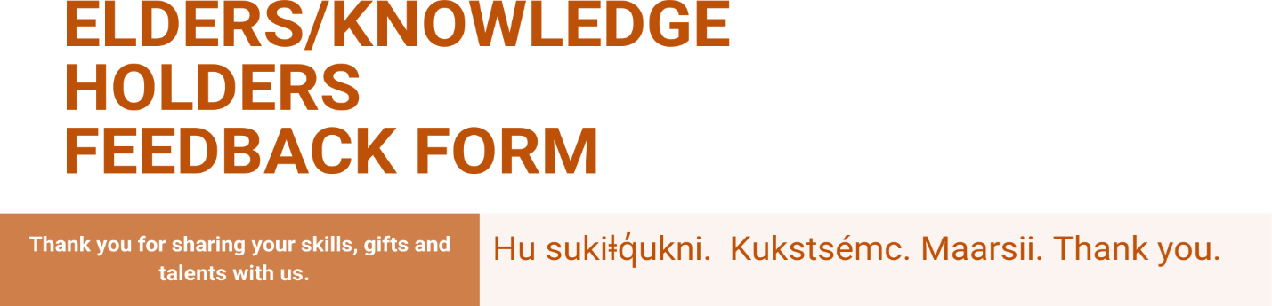

|  |  |  |  |
| --- | --- | --- | --- |
| **Name:** |  | **Phone:** |  |
| **School:** |  | **E-mail:** |  |

How was your experience with us?

Did you have any feedback to help us improve?

# Door Signs

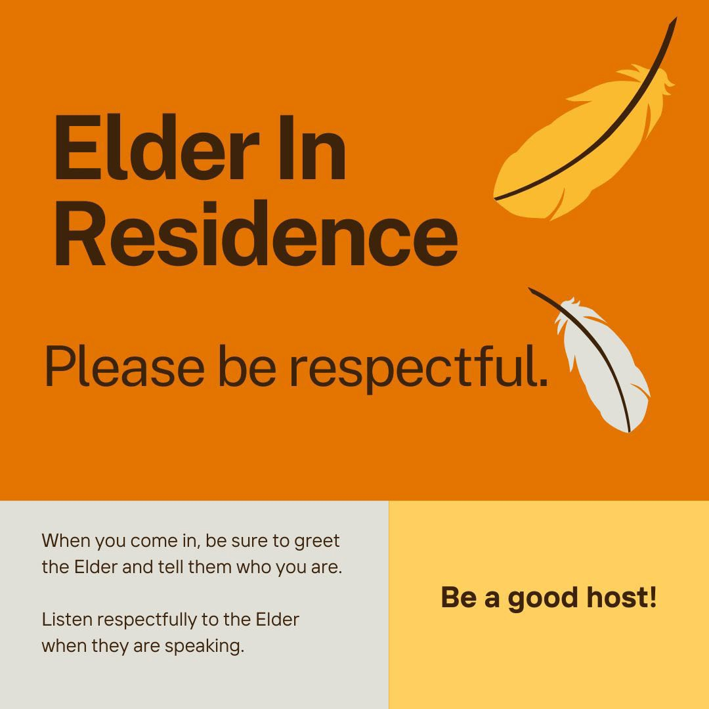

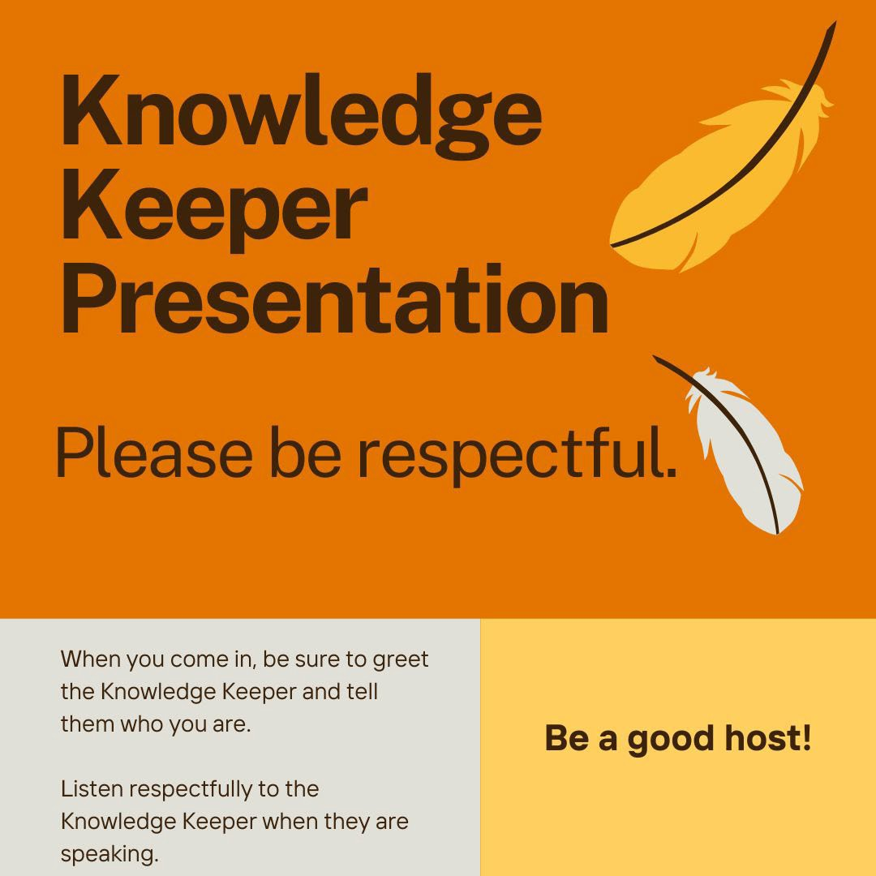

# References

<http://www.hc-sc.gc.ca/fniah-spnia/substan/tobac-tabac/index-eng.php#use> [Focused Education Resources](https://focusedresources.ca/en/k-12-evaluated-resource-collection?search_api_fulltext&field_resource_author&title&field_switcher=search-api-fulltext&field_language=All&field_resource_subject=All&field_resource_collection%5B0%5D=indigenous)

[Searchable Database for Authentic First Peoples Resources](https://resources.fnesc.ca/) [Canadian Indigenous Books for Schools](https://books.bc.ca/wp-content/uploads/Indigenous2019_forWeb-singles_Nov1.pdf)

[Strong Nations Indigenous Labels](https://www.strongnations.com/)

[Cultural Appropriation vs. appreciation (teacher resource)](https://etfofnmi.ca/wp-content/uploads/2023/12/ETFO-Cultural-Appropriation-Revised-2022.pdf) [FPCC-Working-with-Elders_FINAL.pdf](https://fpcc.ca/wp-content/uploads/2021/05/FPCC-Working-with-Elders_FINAL.pdf)

**Other Great Resources**

[https://www.steugene.ca/discover/indigenous-programs/ktunaxa-](https://www.steugene.ca/discover/indigenous-programs/ktunaxa-interpretive-centre/) [interpretive-centre/](https://www.steugene.ca/discover/indigenous-programs/ktunaxa-interpretive-centre/)

<https://www.radiumhotsprings.com/plan-your-trip/visitor-centre/> <https://www.windermerevalleymuseum.ca/> <https://goldenbcmuseums.com/>

[Kimberley Heritage Museum | City of Kimberley](https://www.kimberley.ca/community/culture/museum)